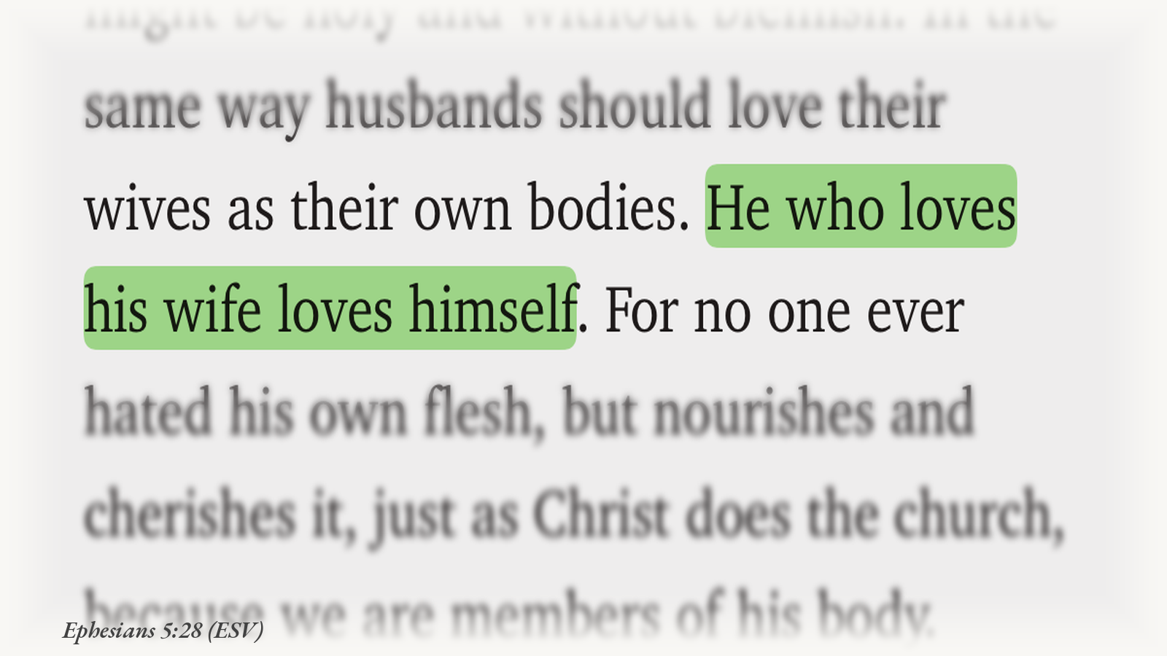

Alice and Her Wonderland
Women. In Nigerian climes especially, we are plagued by a religious stratosphere that keeps us as subordinates, second-rate citizens in this “kingdom of God”, and rather helpless addendums to our counterparts: the fully fledged, completely limbed Adam.
The man is the head; therefore, honour is good for him. All we get are crumbs of love chewed out of him.
Love is this: she looks great when she gets a new ’do. Then she puts on weight after carrying their baby for nine months, coming out of pregnancy with a body not quite as attractive, and not quite a size eight as when they met. But hey: “love is not emotion; love is commitment.”
There is a grievous error heavy in the thickly layered flesh that has hidden the soft, white underbelly of what a perfect God came to the cross for. It is convenient, too, that the people pulling this mass wool over our eyes often ignore the very history of the source they claim contains verifiable truth. They bypass it rather conveniently, actually: the ancient manuscripts, the competing textual traditions, the translation histories, the social worlds in which these texts emerged, and the rigorous, educated work of Hebrew and Greek language study.
They disregard the fact that the Bible did not fall from heaven in one modern language, bound in a single volume, with every word carrying one permanent meaning. The Hebrew Bible is a library assembled across centuries. It has been copied, preserved, translated, debated, and interpreted through Hebrew, Aramaic, Greek, Syriac, and Latin. The Masoretic tradition is not the only witness to the text. There are the Dead Sea Scrolls, the Samaritan Pentateuch, the ancient Greek Septuagint, the Targums, the Peshitta, the Vulgate. These witnesses do not all agree in every detail. That does not make the Bible meaningless. It means that reading it requires more than 2GB of MTN one-day subscription plan and daddy issues.
It requires research.
Take Adam.
In Genesis, the Hebrew adam can function as the name “Adam,” but it can also mean “the human” or “the human one.” It is tied by wordplay to adamah, the ground or soil. A translation that turns every appearance of adam into the proper name “Adam” may quietly make the first human male before the text has finished telling us what this human is. That choice may be traditional. It is not innocent of interpretation.
Then there is ish and ishah: “man” and “woman.” The words are connected in Genesis 2 through sound and wordplay: woman from man, flesh from flesh. But wordplay is not the same thing as a complete theory of woman’s purpose, identity, or rank. Poetry can establish kinship without establishing hierarchy.
And then there is ezer kenegdo.
“Helper suitable for him.”
“Helpmeet.”
“A helper corresponding to him.”
“A helping counterpart.”
“A sustainer beside him.”
The phrase is difficult. It appears only twice in this form in the Hebrew Bible. The word ezer can mean help, but related forms are also used for God as Israel’s help and deliverer. Help is not automatically the language of a servant. The second word, kenegdo, carries the sense of what is before, opposite, corresponding to, or facing him. Ancient Greek and Latin translators wrestled with it too. The Septuagint rendered it in the direction of a helper corresponding to him; the Vulgate used language meaning a help like himself.
The King James Version gave English-speaking Christianity “an help meet for him.” In early modern English, “meet” meant fitting or suitable. It did not mean a woman appointed to domestic servitude. Over time, “help meet” became “helpmate,” and a translation decision hardened into a social imagination.
Some scholars have even argued that ezer in this context may carry associations of strength or power, producing phrases such as “a powerful counterpart.” That proposal is debated; it is not a magic linguistic key that proves every modern egalitarian claim. But neither is “helper” a magic key that proves female subordination. The honest conclusion is smaller and stronger: the Hebrew phrase does not straightforwardly say “a subordinate assistant.” It is more complex than the sermon cliché.
The same care is needed with “headship.” In Ephesians, the Greek word translated “head” is kephalē. Its metaphorical meaning is debated: authority, source, prominence, responsibility, or some combination shaped by context. The word itself cannot do all the theological work that has been piled on top of it.
And the passage does not begin with a husband standing on a platform while his wife kneels below. It begins with a call to mutual submission. Whatever one concludes about the household code that follows, husbands are told to love their wives as Christ loved the church: a love defined by self-giving, not entitlement; by sacrifice, not appetite; by care, not the convenient preservation of male comfort.
So when someone says, “The man is the head,” I want to ask: head in what sense? In which language? In which textual tradition? In which historical world? And why is the husband’s authority preached with such enthusiasm while the demand that he empty himself is reduced to a decorative footnote?
Because what did Christ come to do: make women smaller? Make silence a sacrament? Build a throne for Adam and leave Eve scraping the floor for blessings?
Nigeria is not one thing, and neither is its religious life. Gender hierarchy here is shaped by overlapping forces: religious interpretation, family structures, customary expectations, law, economics, class, politics, and the stubborn authority of “this is how we have always done it.” It is too simple to blame one faith tradition for every injustice. It is equally dishonest to pretend that religious language has no power when it is used to sanctify women’s exclusion, endurance, or fear.
The figures are not abstract. Women remain underrepresented in political leadership, and violence against women remains widespread. These realities cannot be explained by religion alone, but neither can religious institutions pretend to be spectators when their teachings are used to defend them.
It is telling. More than telling, it is convenient that the critics of this mass wool-pulling often bypass the very history of the text. They ignore the ancient versions, the manuscript evidence, the contexts, the evolution of language, and the rigorous study of Hebrew and Greek. They disregard connotation and denotation, grammar and genre, social world and literary design, simply to arrive at the neatest conclusion: “The God of the Bible hates women.”
How utterly simple.
Too simple.
That line should remain a provocation, not a caricature of every critic. Some people are not saying that every biblical believer hates women. They are saying that certain texts and interpretations have been used to produce misogynistic outcomes. That is a serious claim. What it therefore deserves is at least a well-investigated and informed allied intelligence, not a corresponding “gbos” to the “gbas.”
Weighty matters like this ought not to be the thumb-ready substitute for your personal identity.
And if research, in all its confounding, illuminating, and perpetually inconvenient glories, is too much for that “hot take,” then perhaps consider therapy. Or an AI companion.
We, the members of the literati, will be more than glad to welcome you and your glorious wit and active brain neurons back as soon as those issues are addressed to a tenable degree.
Let’s bring back research. Let’s bring back reading. Let’s bring back searching out a matter before sentencing a language, a people, or a God to our preferred conclusion. Let’s bring back Alice and her rabbit hole.
It will mean shocking and challenging colours, creatures, and perspectives. It will mean discovering that a word we thought was settled is not settled, that a translation we thought was neutral has a history, and that the people who came before us were not always asking the questions we are asking now.
But if it means that imagination and truth are not so distinct, I don’t mind. This black-and-white ignominy is egregious.
“Off with their heads!”

Selected references
• Gender and the Hebrew Bible, Bible Odyssey
• Woman: Helpmate No Longer, TheTorah.com
• Septuagint, Encyclopaedia Britannica
• Bible Translation and Gender: Translating Gender, Verbum et Ecclesia
• Ephesians 5:21–33, NRSVUE
• Nigeria, UN Women
All rights reserved. Chika Igidi, 2026.

